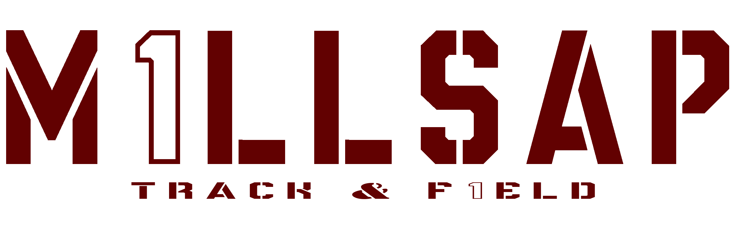
2024 JUNIOR HIGH SCHEDULE
(Most meets start at ~3:30 for field events & 3200m ~5:00 for running)
DATE | MEET | TEAMS | LOCATION
FEB  20th | BROCK | 7th & 8th Boys/Girls | BROCK, TX
FEB  26TH | TOLAR | 7th & 8th Boys/Girls | TOLAR, TX
MARCH  4TH | JACKSBORO | 7th & 8th Boys/Girls | JACKSBORO, TX
MARCH  11TH-15TH | SPRING BREAK PRACTICE TU & TH | 7th & 8th Boys/Girls | MILLSAP, TX
MARCH  18TH | HAMILTON | 7th & 8th Boys/Girls | HAMILTON, TX
MARCH  28TH | DISTRICT TRACK MEET | 7th & 8th Boys/Girls | BRECKENRIDGE, TX

